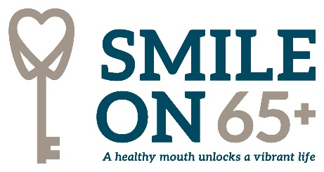
SMILE ON 65+ Referral Form

Referral Partner: ___________________ Today’s Date: ___________________

First Name: _________________MI: ______Last Name: _______________________

Contact Information:

Phone Number: (____)_______________________

Address: _______________________________________________________________

City: ______________________ County: __________________Zip Code: ___________

Smile On 65+ Demographic Information:

Date of Birth: _______________________ Last 4 SSN: _________________

Gender: _____Female _____Male ______ Transgender _____Unknown/Other

Race/Ethnicity: ______Caucasian ______African American _____Hispanic

_____Asian ______American Indian/Alaska Native _____Pacific Islander

_______Multi-Racial _______Unknown _____Prefer Not to Answer

Does the client receive any of the following? (Select all that apply)
________SNAP/Food Stamps ________TennCare/Medicaid _________Section 8/Low

Income Housing ________SSI/SSDI

Is the Client a Veteran? _____ Yes _____ No

When is the last time the client visited a dentist?

____Less than 12 Months _____1-2 years ____3-5 years ____ More than 5 years

What has kept the client from seeing a dentist regularly?
◻ Transportation ◻ Dental Cost ◻ No Insurance
◻ Personal Isolation ◻ Fear ◻ Physical mobility and health

Current dental issues (if any): ____________________________________________

Does the client have DENTAL insurance? _______Yes _______ No_______ Unsure

If Yes – Type/Plan (if known) _____________________ Does client need help using

benefits? _____Yes _____No _____Unsure

Household Income:

$____________________ # of people in household__________

Does the client pre-qualify for SMILE ON 65+ (age, residence, income, and insurance
criteria met)? _____Yes _____No

For eligibility verification, please attach the following:

-Proof of Household Income (proof of any income received for all adults in the household)

-Copy of all medical and/or dental insurance cards, including Medicare

-Proof of Age and Tennessee residence (copy of drivers license or state ID card fulfils both; otherwise include one legal document verifying DOB (passport, birth certificate, social security documents) and one verifying proof of address (utility bill, bank statement, etc.)

Fax completed referral form and eligibility documents to 615-988-9244

or email to mattie@smileon65plus.com

